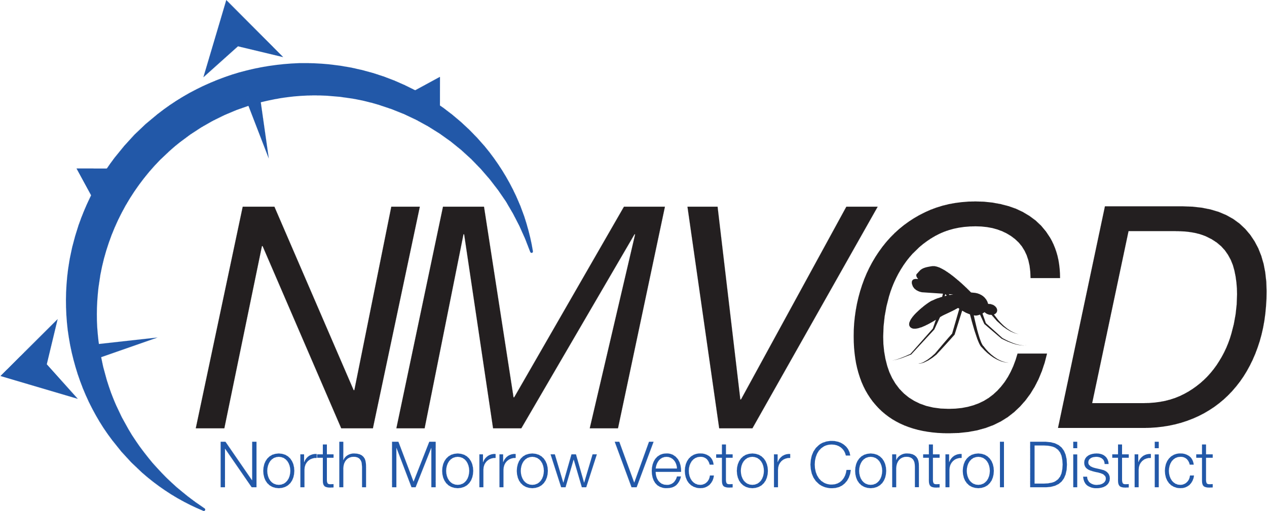“We bite mosquitoes back!”

Agenda

Board Meeting, Tuesday April 23, 2024

Time: 6:30 pm

Location: NMVCD Office

1. Call to order.
2. Approve minutes from previous meeting.
3. Current financial update
4. 2023 Annual Financial Auditors Report (sent by email)
5. 2023 Annual Operational Report (sent by email)
6. Building update
7. POM
8. Purchase Land
9. Hermiston Plan Center
10. Engineering and Building design.
11. Banner Bank-Municipal Loan
12. Budget update
13. Option Levy
14. Good of the order
15. Purchase used pickup to haul larvicides to helicopter LZ.
16. Upcoming mosquito season.
17. Next meeting: Budget Committee Meeting week of May 22nd or 29th ?
18. Adjourn

Email: [gbarron@centurytel.net](mailto:gbarron@centurytel.net)

Website: nmvector.org

Gregory Barron, Manager

P.O. Box 192

3 NE Marine Drive

Boardman, OR. 97818

Phone: 541.481.6082