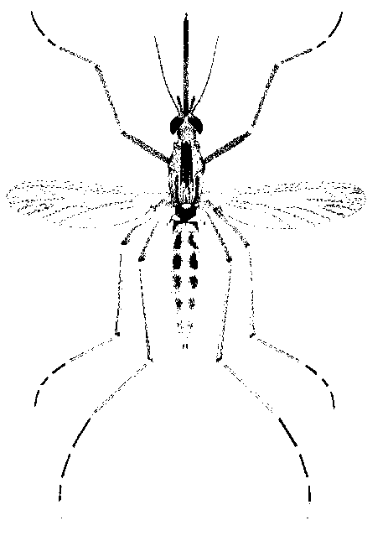
North Morrow Vector Control District
P.O. Box 192 / 3 Marine Drive
Boardman, OR 97818
541.481.6082 Voice / 541.481.6082 Fax (By Request)
gbarron@centurytel.net

May 24, 2023

Meeting Date: Wednesday May 24, 2023
Meeting Time: 6:30 pm
Meeting Location: Vector District Office

Dear Budget Committee:

Meeting Agenda

1) Discusses and approve proposed 2023-24 Operating Budget.

2) Mosquito control update

3) Future of Vector Control at our current location

4) Purchase of ULV Fogger

5) Re-Appointment of Board Members Glenn Maret and Pat Tolar

6) Set Budget Hearing Date

Respectfully,
Greg Barron,
Budget Officer
gbarron@centurytel.net
(541) 481-6082

.

