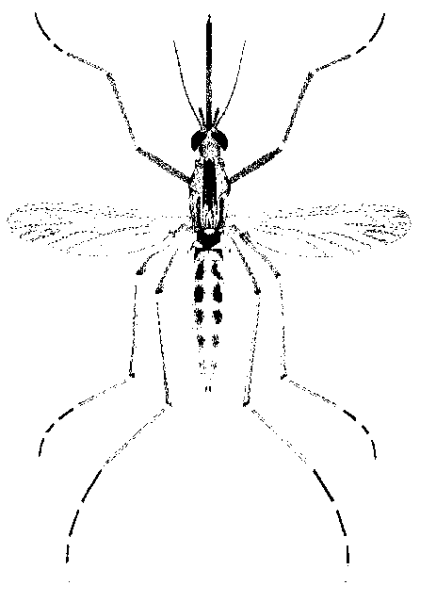
North Morrow Vector Control District
P.O. Box 192 / 3 Marine Drive
Boardman, OR 97818
541.481.6082 Voice / 541.481.6082 Fax (By Request)
gbarron@centurytel.net

May 17, 2023

Meeting Date: Wednesday May 24, 2023
Meeting Time: 6:30 pm
Meeting Location: Vector District Office

Dear Budget Committee:

Once again, we will be conducting our annual budget committee meeting. This will be a dinner meeting at the office. I will serve North Jct. Stew and Taco Soup with all the fixings.

I am emailing copies of all the budget documents and will have copies at the meeting.

Meeting Agenda:

1) Discusses and approve proposed 2023-24 Operating Budget.

2) Mosquito control update

3) Future of Vector Control at our current location

Respectfully,
Greg Barron,
Budget Officer
gbarron@centurytel.net
(541) 481-6082

PS: Please let me know if you cannot attend.

